Kishore Bharati Bhagini Nivedita Coillege (Co-Ed)
148, Ramkrishna sarani, Behala, Kolkata-700060
--------------------------------------------------------------------------------------------------------
TENDER- 3/KBBNC/2019
Date: 24/08/2019

Sealed tenders are invited by the Principal, Kishore Bharati Bhagini Nivedita Coillege, 148, Ramkrishna Sarani, Behala, Kolkata-700060 contact No. (033) 2404 3206 from experienced suppliers for the supply of the items for this institution as per list mentioned below.

For details please visit our College web site: www. http://kbbnc.ac.in/

Related papers for submission of Quotation are available in the Notice published in College web site.

Tender will be received within 31/08/2019 up to 1.00 P.M and tender will be opened on 31/08/2019 at 2.00 P.M. in the chamber of Principal in presence of interested applicants.

The authority reserves the right to accept or reject the lowest or any tender without assigning any reason what so ever.

Selected suppliers must supply within 7 days from the date of purchased order.

Note: Suppliers must submit their relevant experience certificates, professional competence & financial capability for supplying this type of materials with their tender application.

Dr. Shib Sankar Sana
Principal
Kishore Bharati Bhagini Nivedita Coillege

TENDER APPLICATION

To,
The Principal ,
Kishore Bharati Bhagini Nivedita Coillege (Co-Ed)
148, Ramkrishna Palli, Behala, Kolkata-700060.

Sir/Madam

As per your tender no. 3/KBBNC/2019 dated 24/08/2019, your prescribed tender format dully filled and signed by me is being submitted for your kind information and necessary action. I shall abide by all terms and conditions laid down by you.

Signature of the Supplier
With date & Seal

- Name of the Supplier……………………………………………………

- Address:……………………………………………………………

……………………………………………………………………………

- Contract No.:………………………..

Enclosed: List of items .
Item A:
Sl. No. | Item:  Name of equipments | No, of  Unit | Proposed Rate (Rs.), period of warranty & any other offer.
1. | Printer HP Lazer Jet; M1136 | 1
2. | HP Desktop Pro G2 Microtower PC(6AF17PA)  8th Generation Intel® Core™ i3 (8100)processor  4 GB DDR4-2666 SDRAM (1 X 4 GB)  1 TB 7200 rpm SATA HDD  Intel® UHD Graphics 630  No ODD  FreeDOS 2.0  HP V190 46.99 cm (18.5) Monitor | 2

Please mention warranty period and free maintenance and delivery charges if any.

Item B:
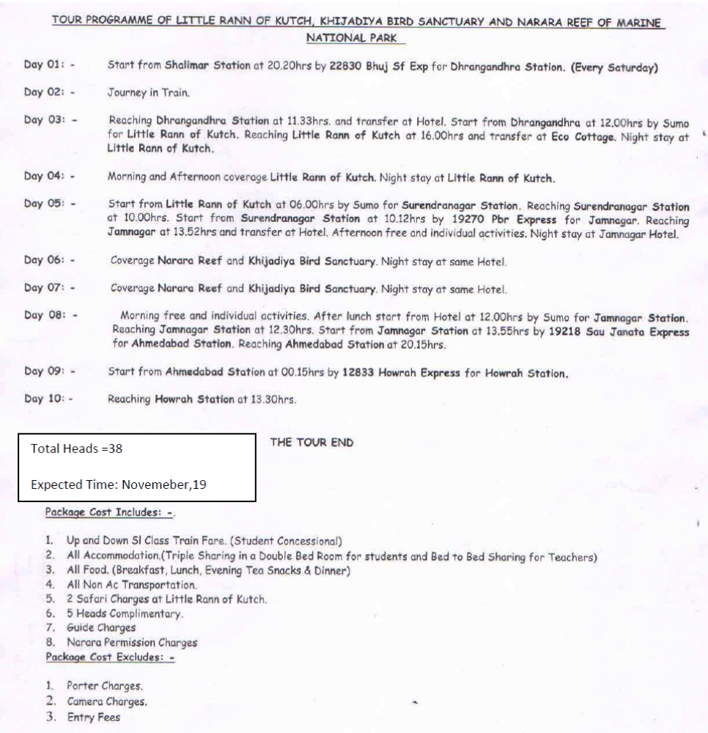

Item C:
DEPARTMENT OF GEOGRAPHY

TOUR PROGRAMME – 1/2
HARDWAR- DEHRADUN – MUSSOURIE
HOWRAH TO HOWRAH – 9 NIGHT / 10 DAYS

DAY | DATE | DETAILS | DESTINATION /NIGHT AT
1 | 2020  FEB. | START BY TRAIN UPASANA EXP. FROM HWH @ 13-10 HRS. | TRAIN
2 |  | ARRIVE HARDWAR @ 16-00 HRS . AND TRANSFER TO HOTEL  OVERNIGHT STAY IN HARDWAR | HARDWAR
3 |  | FULL DAY FIELD WORK | HARDWAR
4 |  | FULL DAY SIGHT SEEING – HARDWAR – KANKHAL – HRISHIKESH –  LAXHMANJHOLA | HARDWAR
5 |  | AFTER BREAK FAST PROCEED TO MUSSOURIE@ 8 -00 HRS  ARRIVE MUSSOURIE @ 11-00 HRS.  REST OF THE DAY FREE FOR PERSONAL MOVEMENT | MUSSOURIE
6 |  | FULL DAY SIGHT SEEING – KEMPTY FALLS – MUSSOURIE LAKE AND DHANOULTY | MUSSOURIE
7 |  | AFTER BREAK FAST PROCEED TO DEHRADUN 9-00 HRS  ARRIVE DEHRADUN @ 10-OO HRS. | DEHRADUN
8 |  | AFTER LUNCH START DEHRADUN SIGHT SEEING AND DROP AT DEHRADUN STATION IN THE EVENNING  START BY TRAIN DOON EXP. FROM DEHRADUN 20-30 HRS. | TRAIN
9 |  | RUNNING | TRAIN
10 |  | ARRIVE HWH @07-00 HRS. | -------------

Total Heads: 20(16 students and 04 staff )
Note : 04 staff complimentary
RATE INCLUDES –
FOOD , ( BED TEA , BREAK FAST , LUNCH , AFTERNOON SNACKS , DINNER )
ACCOMMODATION IN HOTEL TOTAL 7 ROOMS FOR 16 STUDENTS AND 4 OFFICIALS
ALL SIGHT SEEING AND TRANSPORTATION AS PER TOUR ITENERARY
AND SINGLE SIDE RAILWAY FARE

RATE EXCLUDES – , ENTRY FEES, GUIDE CHARGES , BOATING AND OTHER EXPENSES NOT MENTIONED IN RATE INCLUDE PART

Item D: GRILL, IRON WORKS AND FIBRE SHEET WORK FOR COLLEGE GATE, GARDEN SHED AND OUTSIDE DOORS.
All iron material must be of Shyam galvanized iron rods or sheets
- 2 Fibre Shed for covering the outside garden area
- 19’0’’ x 4’6’’
- 5’0’’ x 9’0’’

- 2 Arch gate for the two entrance of college
- 92’’ x 78’’ x 8’’
- 101’’ x 104’’ x 8’’

- 4 Garden railing on both side of the gates of about 4’ height with latch system

- Iron Sheet gate for bathroom – 7’0’’x 3’6’’

- Iron Sheet gate for canteen – 6’6’’ x 3’0’’

